Experiment 8 –To perform File transfer in client and server using the TCP/IP  
  
Server Side (server.py) –

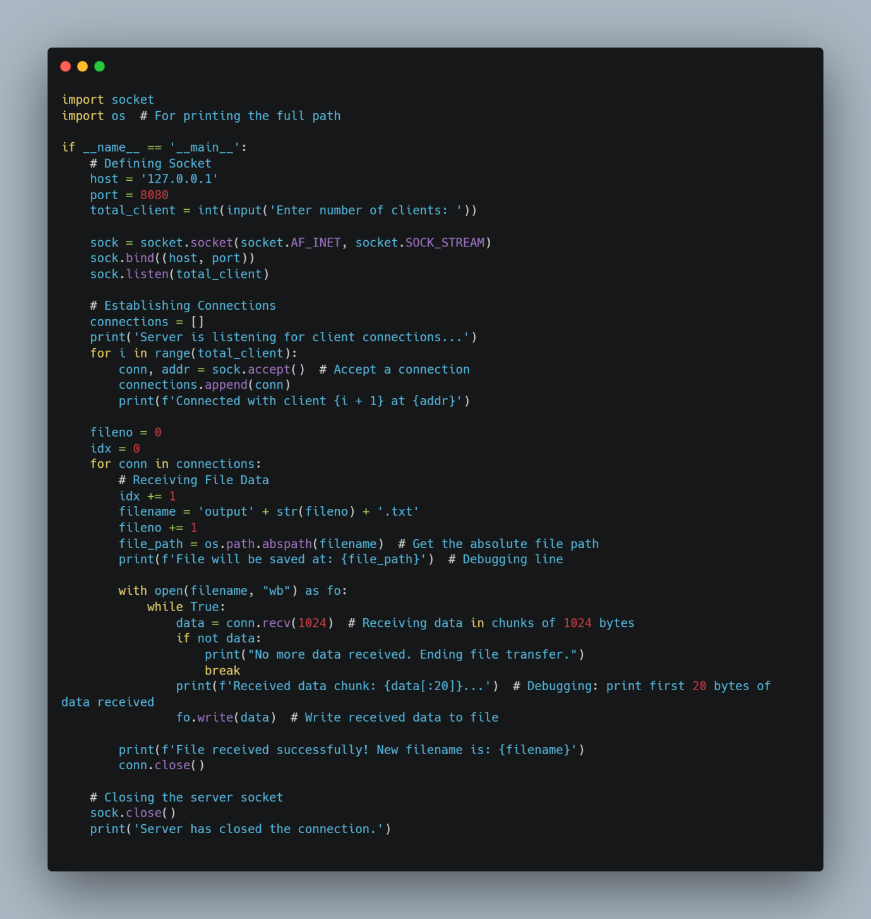

Client Side (client.py) –

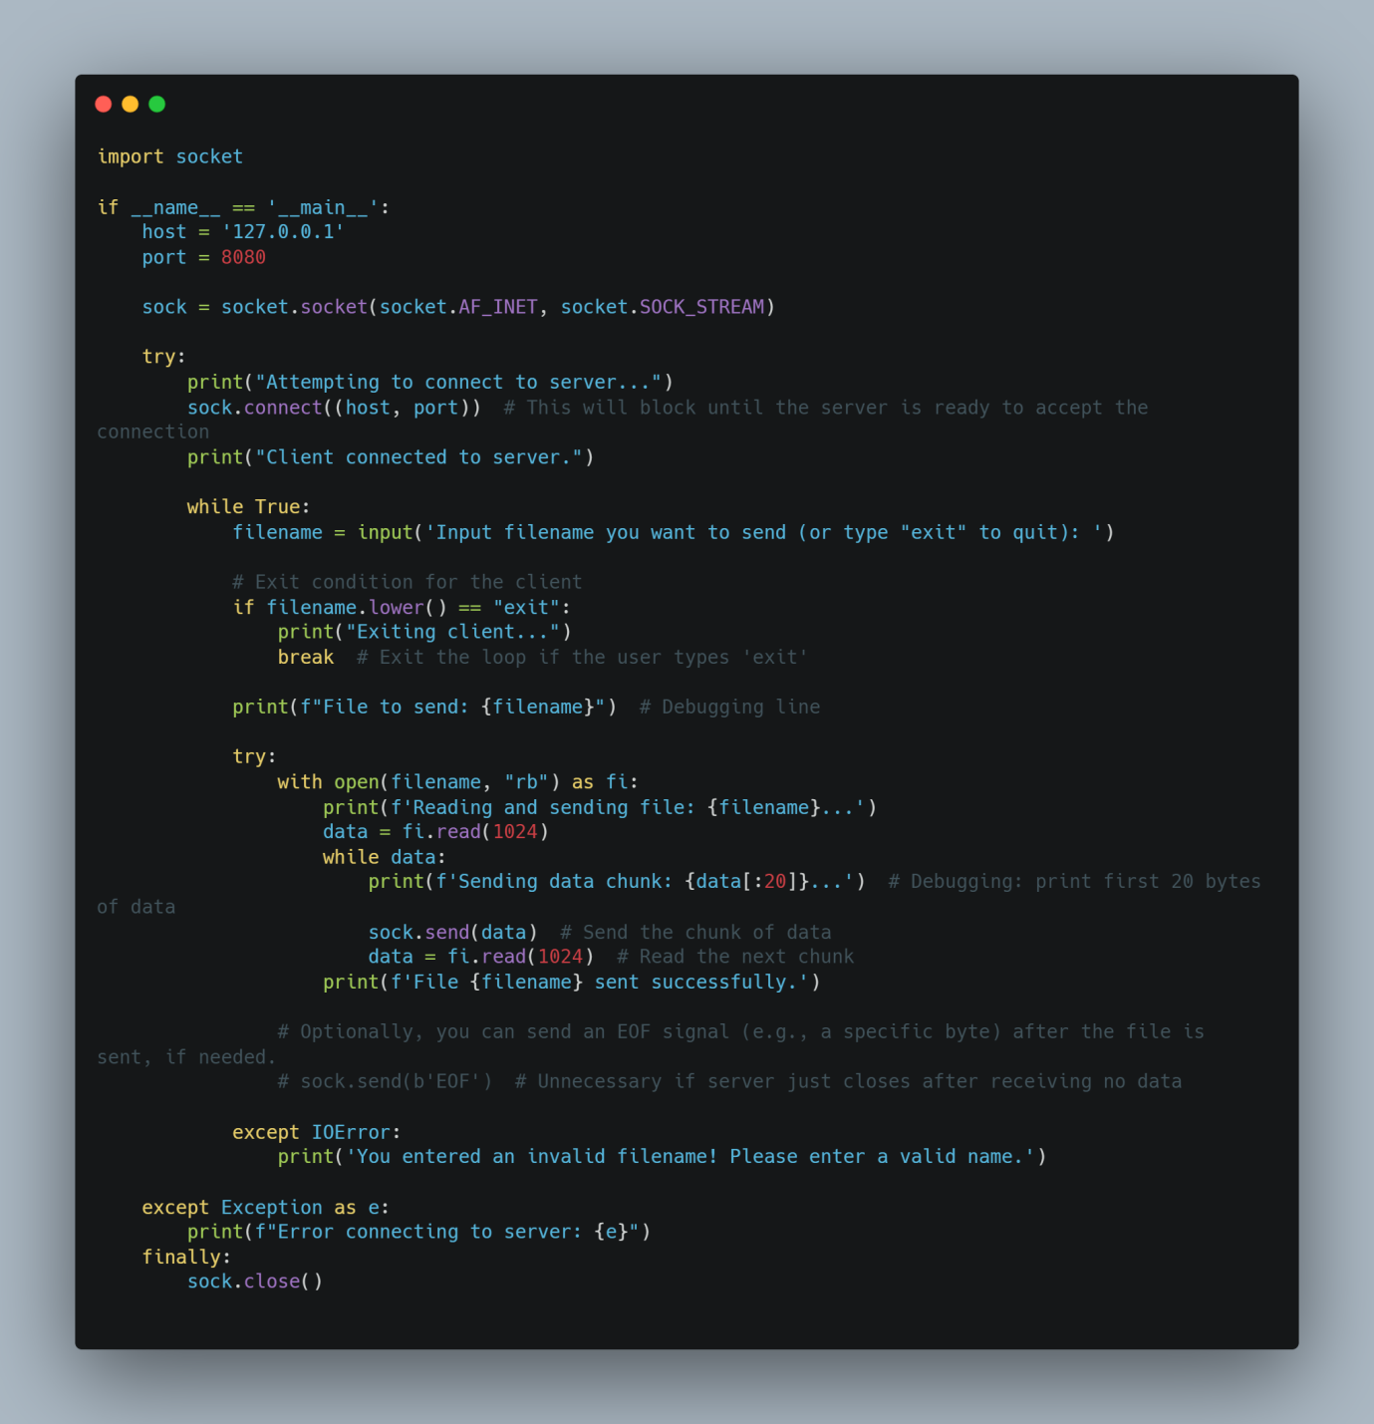

Test file  
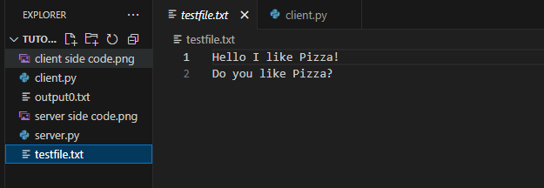

Output

1] Type in server.py into the terminal  
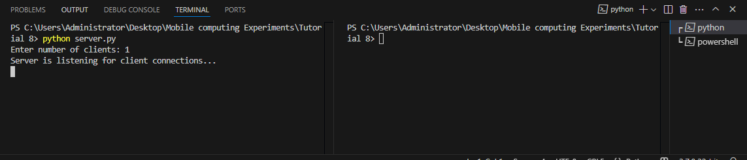

2]In separate terminal, type in the file name you want to send, in this case its testfile.txt  
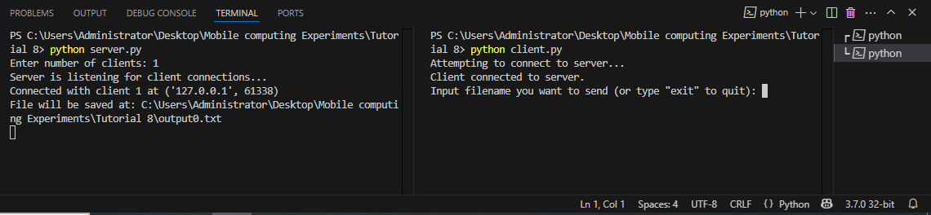

3]Once file is sent, type in exit into the terminal, your file should be visible  
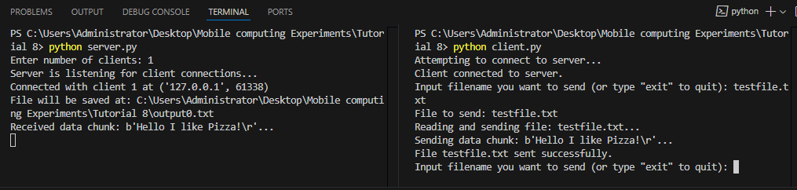

4] File successfully sent  
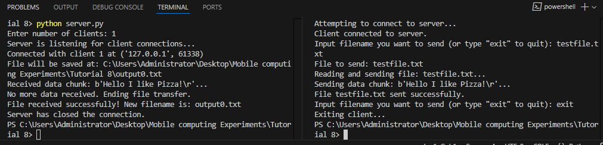

5] OUTPUT  
